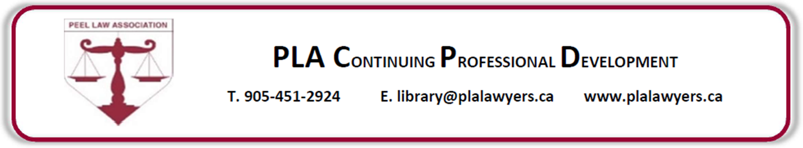
Dispute Resolution (DR): What you need to know
about the Divorce Act amendments and more…

Tuesday, March 2, 2021

4:00 pm to 5:30 pm | Online with ZOOM

Presentations by the Peel Med-Arb Group  This program will briefly discuss the Divorce Act amendments and a lawyer’s responsibility to advise clients about Dispute Resolution (DR) processes, as well as, the voice of the child. The majority of the program will focus on the Dispute Resolution options available and how you can prepare your client for the mediation and/or arbitration process. |  |  |  |  |  |  | 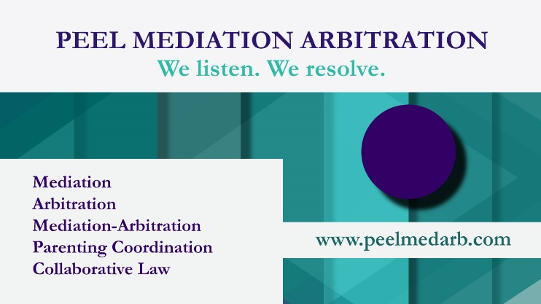
Once registered, you will receive the login details on the MORNING of the presentation.
REGISTRATION WILL CLOSE at 12:00 Noon on the DAY of the PRESENTATION.
Please advise the PLA in writing and in advance of any special accommodations.
This program contains 1.5 Professionalism hour(s) toward the
Law Society of Ontario – Continuing Professional Development requirements (CPDs).
REGISTRATION FEE & PAYMENT OPTIONS:
☐ $28.25 (includes HST) 2021 PLA Member |  |  |  |  |  | ☐ $56.50 (includes HST) Non PLA Member
☐ | ONLINE  (Visa, MasterCard, American Express) |  |  |  | ☐ VISA* |  |  |  | ☐ MASTERCARD*
 |  |  |  |  | *Payment to be authorized over the telephone (905-451-2924).
Registration & Cancellation Policy: You are not registered until your payment is received. No refunds will be issued unless 48 hours written notice is provided prior to the event.
Name:  (MUST be displayed  in webinar) |  | Click or tap here to enter text. |  |  |  | Telephone:  (MUST be displayed if calling into webinar) |  |  | Click or tap here to enter text.
Email:  (required to receive login information) |  |  | Click or tap here to enter text.
OFFICE USE ONLY - Method of payment: ______________________ |  |  |  |  |  |  |  | Date received: ________________________

